

Relax metal with vibration

**MEMV_ Rubber Pads_ WM945**

**hpw_2019_**Updated April 2019

***WM 945_0 content:***

*WM945_1 Foreword*

*WM945_2 rubber information*

*WM945_3 Plates MEMV vibrate*

*WM945_4 MEMV impeller vibrate*

*WM945_5 110 tons MEMV component vibrating*

*WM945_6 60 tons of MEMV component vibrating*

*WM945_7*

*WM945_8 Closing remarks*

***WM 945 1 Foreword***

Relaxing metal with vibration The WIAP MEMV system hides a few things that make metal relaxing with vibration safe for a process-safe process. Among other things, it is very important that the rubber pinch and the position of the rubber are taken into account. In previous WIAP operating instructions, the view was always that it would be better with only 3 editions. However, new measurements have shown that it is better if four supports are not subjected to deflection of the components or too high a point load. In addition, since WIAP was able to take many measurements with the measuring stick in 2014. It was also measured that in the vicinity of the rubber, when highly loaded, there is less excitation in the component than in zones further away from the rubber pad position. For this reason, the report specifically about the rubber is an important finding,

***WM 945 2 rubber information***

|  |  |  |  |  |  |
| --- | --- | --- | --- | --- | --- |
| MEMV-G-0 | Rubber size 0 | |  | | --- | |  | | | **Rubber with inner grip hole 50 Shore 40x100x200 Kg** |
| MEMV-G-1 | Rubber size 1 | |  | | --- | |  | | | **Rubber with inner grip hole 50 Shore 80x100x200 Kg** |
| MEMV-G-2 | Rubber size 2 |  | **Rubber with inside handle hole 50 Shore 120x100x200 Kg** | |
| MEMV-G-3 | Rubber size 3 |  | **Rubber with inside handle hole 50 Shore 150x200x200 Kg** | |

**metal relaxation systemWIAP MEMV®Rubber underlay system**

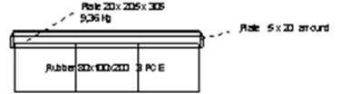

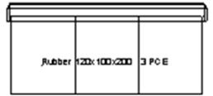

**Single rubber system**

|  |  |  |  |  |  |
| --- | --- | --- | --- | --- | --- |
| rubber size | bruise | bruise | bruise | bruise | bruise |
| H x W x L | 60% | 40% | 25% | 10% | 5% |
| ***H x 0.4*** | ***H x 0.6*** | ***H x 0.75*** | ***H x 0.9*** | ***H x 0.95*** |
| 80x100x200 | 43200N | 28800N | 18000N | 7200N | 3600N |
| 120x100x200 | 43200N | 28800N | 18000N | 7200N | 3600N |
| 200x150x200 | 64800N | 43200N | 43200N | 10800N | 5400N |

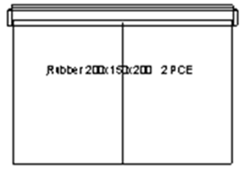

**Heavy-duty system, single rubber system 3 x 1 piece small or 2 x 1 piece large**

|  |  |  |  |  |  |
| --- | --- | --- | --- | --- | --- |
| rubber size | bruise | bruise | bruise | bruise | bruise |
| H x W x L | 60% | 40% | 25% | 10% | 5% |
| 80x300x200 3 pcs | 129600N | 86400N | 54000N | 21600N | 10800N |
| 120x300x200 3 pcs | 129600N | 86400N | 54000N | 21600N | 10800N |
| 200x300x200 2 pcs | 129600N | 86400N | 54000N | 21600N | 10800N |

Best vibration damping results when pinch between 5 to 10%

Load as end stop (impact load) - permanent (max.): fmax = H × 0.50

Load as end stop (impact load) – rarely (max.): fmax = H × 0.60

Continuous load - static (max.): fmax = H × 0.15

Vibration damping: fmax = H × 0.05 to 0.10 × H

Data Collection Gum Information

5% or 60% contusion whether this also has an influence on the G measurement

WM 945_3 Plates MEMV vibrate, individually and several

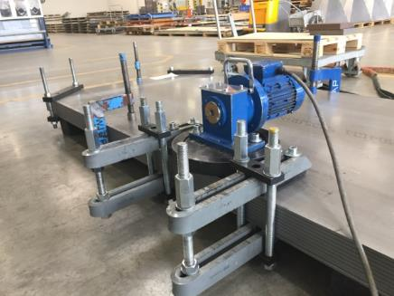

Image 1: Sheet metal plates clamped together, 20 pcs.

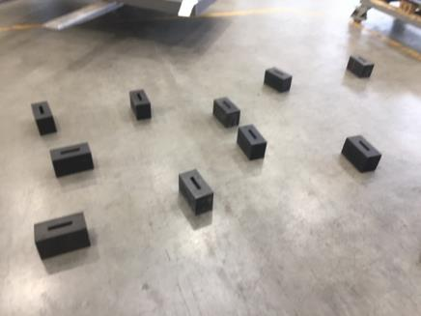

Figure 2: Plate vibration. Sufficient rubber pads 100x200x120 10 pcs.

WM 945_ 4 MEMV impellers vibrate up to a diameter of 3200 mm

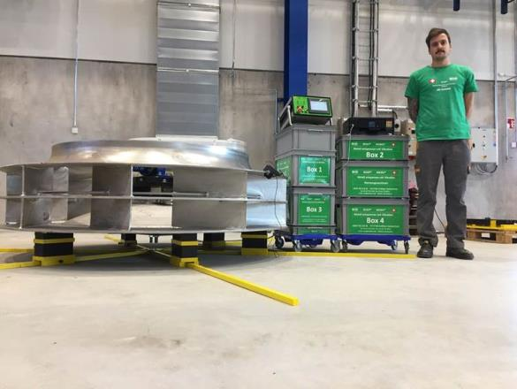

Picture 3:**WIAP® MEMV®**relax from duplex impeller. Jim Peter Widmer with the WIAP MEMV E fully automatic control unit and printer logs measurements before and after.

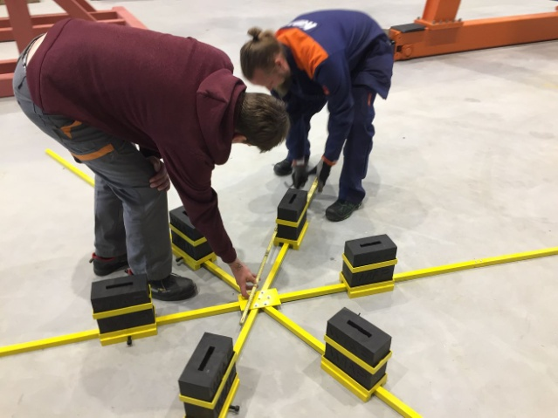

Image 4: The**WIAP® MEMV®**6-Star support device is set in the positions of the 1300 mm diameter support. This prevents the rubber pads from moving away during resonance movements. At best, also that the operators prevent it from tipping over when stepping on the impeller. The outside diameter of the impeller was 1500 mm; the rubber has a radius of 650 mm.

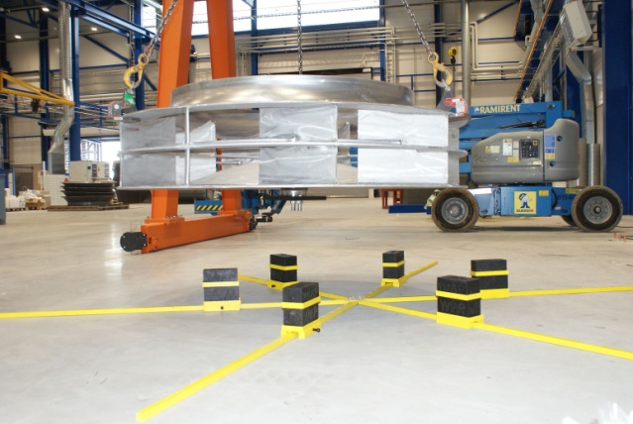

Image 5: The impeller when placed on the secured rubber pads.

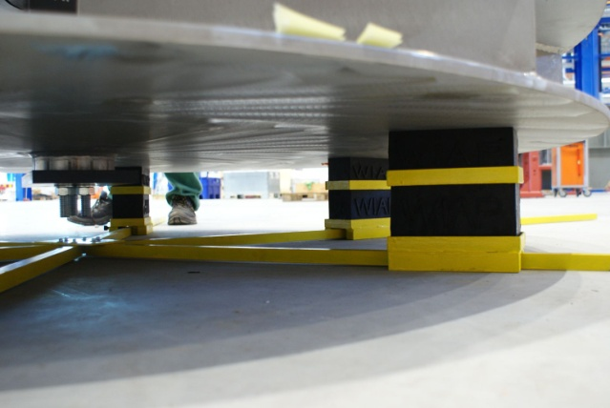

Image 6: The edition of the secured documents.

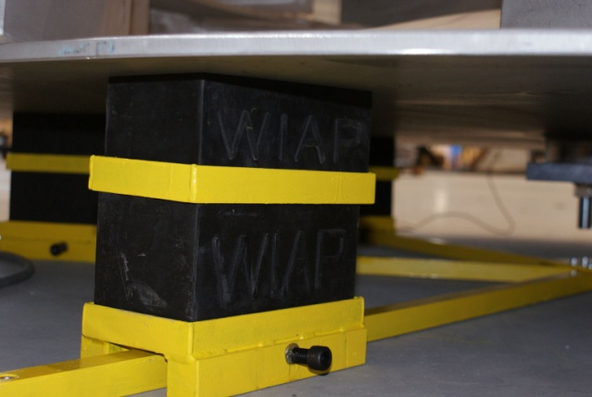

Image 7: This ensures that the slipping away if a natural resonance is overridden and if there is too long, strong vibration.

WM 945_5 110 tons component MEMV vibration

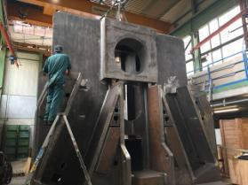

Photo 8: Jim Widmer attaching the lifting ropes.

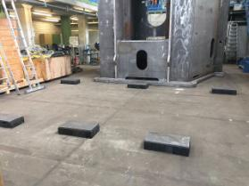

Figure 9: Rubber pads for 110 tons: (See more details from report WM877 60 tons).

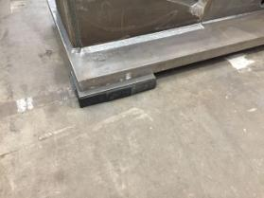

Figure 10: Rubber pads 300 x 600 mm

WM 945 _ 6 60 tons MEMV component vibrating

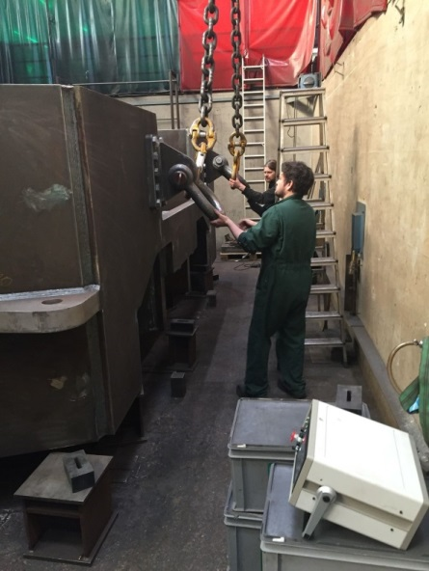

Image 11: Sven Widmer preparing the 60 ton component.

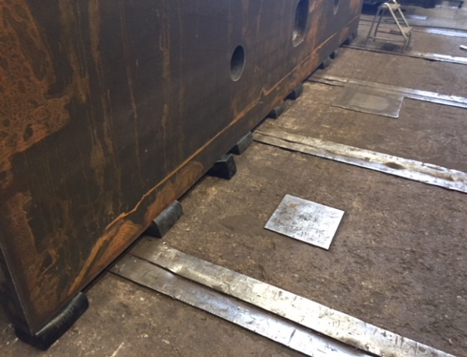

Picture 12: The rubber bruise was big.

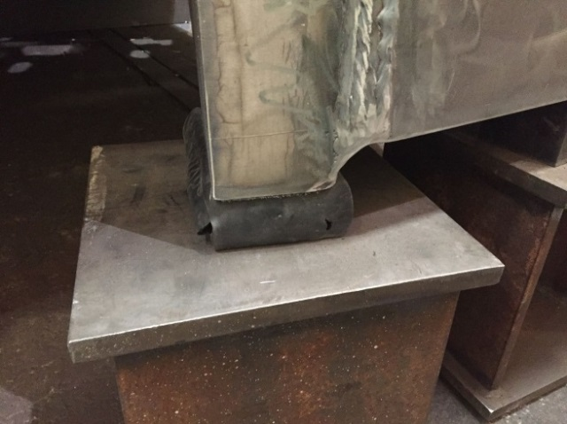

Image 13: Here the 60% of the rubber squeeze was reached, more should be avoided.

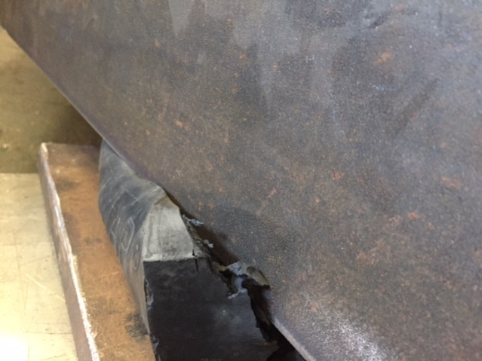

Photo 14: Here the uneven surface has put too much strain on the rubber. Since the component here was made of narrow lower plates, an upper plate should prevent the rubber from being damaged.

**WM 945_7**

**WM 945_8 Closing word rubber information**

The fact that the rubber pads are very important for the WIAP MEMV vibration has been shown in component tests in recent years. A component is stimulated evenly if there are enough supports under the component. If the individual point loads are not too great, a better distribution of the longitudinal, transverse and shear waves can take place. A single rubber pad cushioning should be minimized and if the 15% resilience is not exceeded it is a good solution. For this reason, it is better to plan more than fewer documents for a component. It is important not to save when purchasing rubber. The right choice of rubber is also important. Enough rubber pads. Choose the right hardness. Buildings with basements should be viewed with caution, i.e. always take a good look at whether vibrations are transmitted to adjacent zones. If yes, increase the rubber height from 80 / 120 to 200 mm.

Protect rubber from light so that it does not harden. Replace rubber when hard. Do not save, otherwise the results will be insufficient for the MEMV process.

Dulliken/Safenwil 9.4.2019

Thank you greetings WIAP sw, jw, iw, hpw